User Manual

# The Main Dashboard

## 

The main dashboard contains the main components for the program. Each function will be detailed below.

# Write Student Data to second worksheet

This function will take the file in the directory in the worksheet named import.dat, and write the details to the prepared second worksheet included with the program. Please don’t touch that sheet.

# Add Enrolments.dat to Enrolments table

This function will take the file in the directory the workbook is stored in and add it to the enrolments table in the database.

# Query Database for Student Information

This function will create a new sheet named student list and will query the database for Student names, email, city and write them to a new sheet.

# Import from File to Array

Reads the Teb-delimeted file and writes the data into an array

# Add student to new sheet

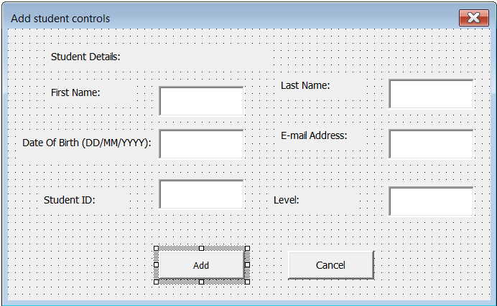

Will open a userform that allows the user to enter in student information. Upon pressing ‘add’ it will c heck for a new sheet, if it does not exist it will make one, it will then format it and write the appropriate information to the sheet.

# Select Students By City

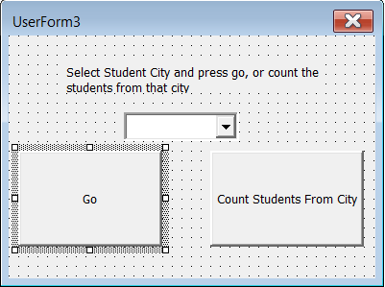

Has a drop-down box that has cities listed in the database, upon selection it will write the information of the students form that city to the sheet.

## Count Students From City

After selecting a city it displays the students from that city

# How Many Students from St.Jacobs?

Uses the SQL query

SELECT [First Name],[Last Name],Address FROM Students WHERE City LIKE '%St.Jacobs%'

To answer the above question.

# Generate Report, Failures,Enrolments

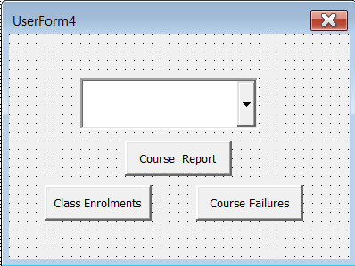

Displays this userform and the options will be displayed below. A course/term must be selected first

## Class Enrolments

Shows the Students enrolled in the course specified.

## Course Report

Displays a report in the course specified. (DOES NOT WORK, this is due to time constraints. And I cannot make this work and write to the sheet. I apologise Professor, I hope you’ll look at my code and see where I went wrong. I am sorry I really looked forward to implementing this)

## Course Failures

Displays all grades less than 50 with the course specified (Again, does not work. I don’t know what’s wrong with this one. I think my query works but it’s not writing to sheet.)